CURRICULUM VITAE
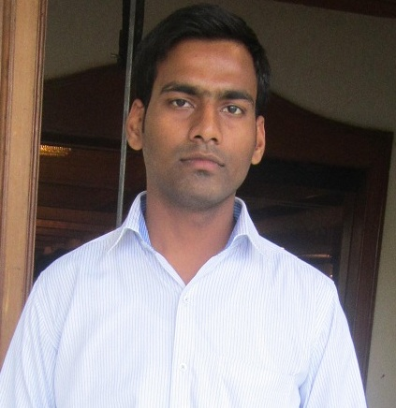
Name:- SANDEEP KUMAR
E-mail:- sk65532@gmail.com
Mobile No: +91-9930262357,
C/O-Lal bahadur singh,

Objective :

To grab an opportunity and set myself a goal where I can be innovative and attain a challenging position by exercising my interpersonal and professional skills to the fullest for the growth of the organization and mine as well.

Academic Qualifications :

Degree | Board / University | Year | % marks
B.TECH.(electronics and communication engineering) | PUNJAB TECHNICAL UNIVERCITY | 2010-2014 | 63
12TH | Bihar School Examination Board | 2010 | 60
10TH | Bihar School Examination Board | 2008 | 60

Technical Skills :

Programming Languages : C & C++
Operating Systems : Windows 98/XP/7/8.
Embedded System : 8051 uC, Basic Knowledge of AVR
Softwares : Keil, Xilinx ISE 9.2i & Matlab.
TRAININGS

- DONE TRAINING IN ROBOSAPIENS PRIVATE LIMTED (NOIDA)
  - ON Robotics with Emmbeded C
  - Duration 45 days.
- DONE TRAINING IN HCL INFOSYSTEMS LTD.
  - ON Installation, Commissioning & Maintenance of Telecom, Hardware, Setting Up of Local Area Network & Wide Area Network(IT) at Carriage Repair Workshop Project (Indian Railway),Harnaut, Bihar.
  - Duration 6 months.

B.TECH. ACADEMIC PROJECT
1.light Sensor Circuit.
2.Make a Electricity Detector.
3. street light power saver project.
Strong Points in Myself :

. Hardworking towards the achieving the Goal.
. Intellectual thinking.
. Flexibility in technical area.
. Always wants to be in discipline.
Area Of Interests :

- In field of
  - Telecommunication.
  - Electronics.
  - Networking.
Extra Curricular Activities/Achievements:
.Certificate of NSS by MINISTRY OF YOUTH AFFAIR & SPORTS, GOVT. OF INDIA.
.Industrial visits -VIDEOCONE JALANDHAR.
Personal Profile :

Name : SANDEEP KUMAR
Father’s name : LAL BAHADUR SINGH
Date of Birth : 3rd-FEB-1993
Gender : Male
Marital Status : Single
Languages Known : Hindi AND English.
P.Address :Bhabua ward no-11,Dist-Kaimur(Bihar)pin-821101

Declaration:

I hereby declare that the above written particulars are true to the best of my knowledge and brief.
Date: 1/08/2014
Place: MUMBAI. sandeep Kumar

